

Active Thermal Management

The trusted name in thermal protection

Parts list – before proceeding, check that you have received all of the following:

(1) Cool-cube motor/fan unit (1) 4” to 3” adapter (3” model only)
(1) Hot air collector (1) Thermal probe
(1) 3” or 4” flexible tubing (1) Power supply

Instructions for installation of the Cool-cube-E™

The Cool-cube will move moderate amounts of heated air from an enclosure to a point up to 6 feet away (8 feet with 4” tubing). It can be ordered with either 3” ID or 4” ID/6” OD tubing, and is powered by a group of five high-quality 120mm axial-flow fans mounted within a small enclosure. A flexible cooling system, Cool-cubes are often used to ventilate smaller closets housing home theater equipment and enclosed video projectors (up to about 300 watts power consumption).

The speed of the fans is controlled by an electronic thermal control assembly which will turn the fans on at slow speed at approximately 82-84 degrees and switch to full speed at 88-90 degrees (F). The electronic switching is controlled by the temperature of a remote probe. In normal operation, the fans should run at low speed only; operation for significant periods at high speed may indicate that the Cool-cube is either underpowered for the amount of heat to be removed, or cannot breathe freely due to an intake opening that is too small.

The fan assembly is slightly more efficient when used to PULL, not PUSH, hot air from the enclosure; i.e., the tubing should be connected (using the clamps provided) to the suction end of the fan assembly, and not the pressure end, if possible. (The pressure end is the end at which the fan manufacturer's label can be seen on the hub of the end fan by looking into the assembly.)

Installation involves cutting a 2 ½" - 2 5/8" hole (3" tubing; 4" for 4" tubing) in the enclosure, mounting the hot air collector over it, and running the tubing to the Cool-cube’s intake port..
The hole should be made in the enclosure at a point where heated air would be expected to accumulate. The top of the rear panel, or the top of an internal compartment in which the heat-generating equipment is located are typical locations.

Equally important as the location of the exhaust point is the size and location of a fresh-air inlet. Heated air cannot be exhausted unless fresh make-up air can enter.

The best location allows entering air to flow around the heated equipment as it moves toward the exit point; an entry opening that lets air flow directly to the exhaust port without "washing over" the equipment to be cooled will not produce maximum cooling.

The thermal probe connects to 2-pin connector TH on the control unit, then is placed where it can sense enclosure and/or equipment heat; it can be held in place by peeling the release paper from the probe holder and adhering it where it can sense the heat of the component whose temperature is being monitored.
1
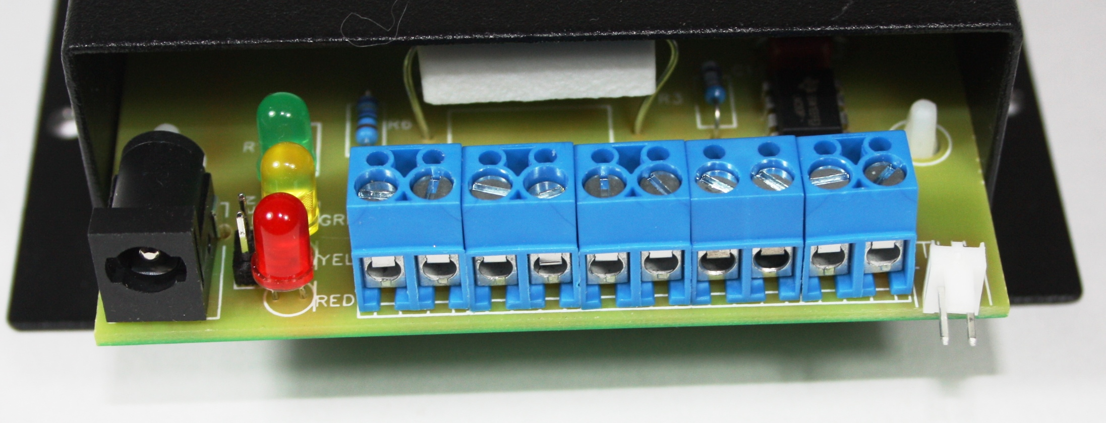
With the thermal probe connected to the control box, plug the power supply output lead into the dc power jack on the control box, then plug the supply into any always-live AC socket. The green led will light, indicating that the Cool-cube is receiving power.
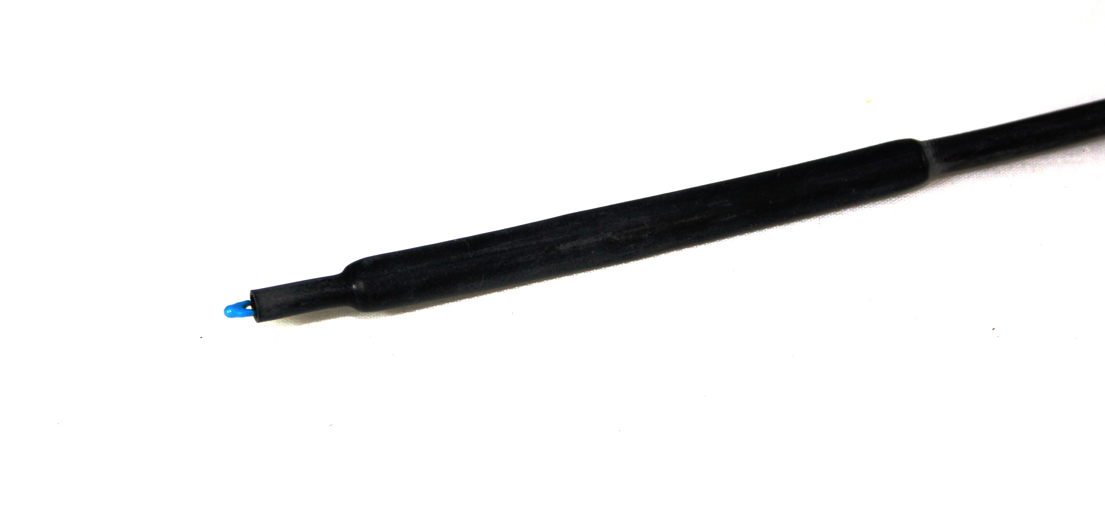
The fans operate at low speed between approximately 84 and 88 degrees, (the yellow led will light) and switch to full speed (both yellow and red leds will light) above 90 degrees.

There is a full-speed lock-out provision on the pc board in the controller. Call tech support at (818) 489-9485 for instructions on how to activate this feature; when activated, the Cool-cube will not run at full speed at any temperature. It should be activated only when low speed is known to provide sufficient cooling and momentary operation at full speed must be avoided, such as in a bedroom installation.

