
[Grab your reader’s attention with a great quote from the document or use this space to emphasize a key point. To place this text box anywhere on the page, just drag it.]

Active Thermal Management

The trusted name in thermal protection

Cool-vent II Installation Instructions 2023

The Cool-vents are compact self-contained air moving devices for use in enclosures housing heat-producing equipment. They can easily be field-modified to work in either intake or exhaust mode. If used as an intake device, provisions must be made to allow the escape of hot air; similarly, when used in exhaust mode, there must be an opening through which room air can enter.

Cool-vents are powered by a plug-type power supply and are controlled by a thermal probe connected to a small module, switching on at about 88-90 degrees. They mount on a finished surface through cutouts shown below.

 | Rough opening | Finished size | Number/size of fans
 | 4⅛" x 14⅛" | 5 ½" x 15 ½" | 4/80mm
As shipped, Cool-vents are assembled as an intake device; air is pulled from the grille side through the fans.

When the fan and grille sections are detached (wood grille units only), the Cool-vent can be changed to operate in either intake or exhaust mode.

- In intake mode, it can be mounted low on a cabinet to bring room air in.

- In exhaust mode, it can be mounted above or behind an amplifier or another heat-producing component to expel heated air.

Main installation step
Separate the fan and grille sections – wood grille units only.
- Finish the grille as required.
- Reassemble in intake or exhaust mode.
- Install in opening.
- Install thermal switch and connect to power source.

In order to protect the grille and prevent warping or cracking, you must seal the grille on EACH side and in between all slots prior to installation.

Whether you are painting, staining, or sealing the grille with urethane, they must have the appropriate finish applied BEFORE they are installed. If the grille is not protected in this way, Active Thermal Management will not be responsible for any warping or cracking that might occur.

To change to exhaust mode, unscrew the fans from the mounting plate and turn them over; fans' labels should now face the grille.

- Reassemble the two sections in desired operating mode. Do NOT use excessive force when tightening the screws holding the fans.

- Cut an opening of appropriate size (see chart above) at the desired location. Pass the thermal probe and power supply through the opening and fasten the grille to the mounting surface either from the outside or inside as appropriate.

- Attach the probe to the equipment to be monitored or mount the probe so that it can sense the temperature of the hottest air in the enclosure. (This might be at the highest point in the cabinet or just above the hottest component.)
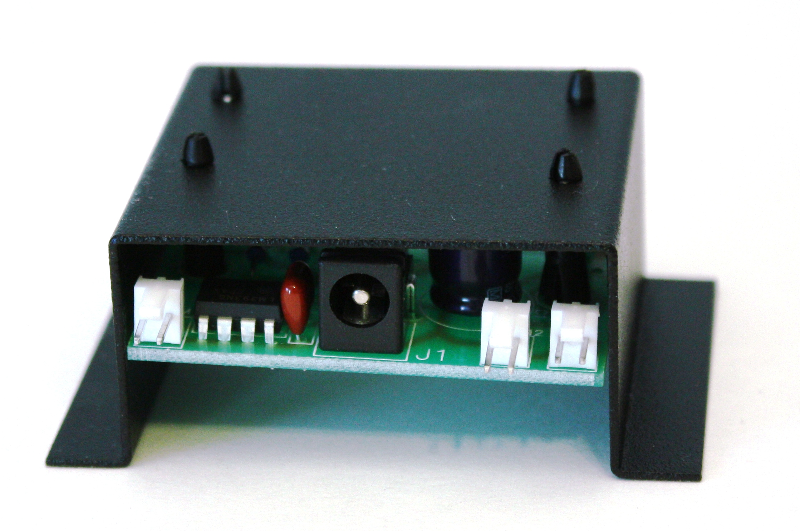

Connections & Operation

After mounting the fans, select the location for the fan controller. Run the fan wires to the controller and plug them onto the connectors FAN 1 or FAN 2. Plug the thermal probe’s cable onto the connector THRM on the controller. Plug the power supply into an AC outlet that is always live and plug the power supply’s output lead into J1 on the controller. The green led should light. When the probe’s temperature-sensitive tip reaches approximately 88-90 degrees, the fans will begin to turn, and the red led will
Fan 1, Fan 2
THRM
light.
Use a hair dryer to test the system; do NOT use an open flame or heat-shrink gun.

