A white paper from Active Thermal Management
The trusted name in thermal management…

By Frank Federman, President

Cooling small equipment cabinets

Cool that computer (and your PlayStation®, Too!)

Whether it’s the hard drive in a multi-media computer or in an office PC, losing programming and data is nothing to laugh at. The computer is becoming part of the home theater, and, as such, needs cooling as much - or more than - the receiver and satellite box. But like other home theater equipment, computers (and video games) are increasingly being put “out of sight” into enclosures that interfere with ventilation.

The result is frequently erratic (or no) operation due to overheating. Computer fans are effective at moving the heat from the hottest internal components out of the case, but if the hot air is then trapped in a cabinet, it gets pulled back into the computer, causing temperatures to spiral upwards.

We’ve written other papers on cooling mid-size and large enclosures full of audio-video gear (available at www.activethermal.com/technical _info) but here we’ll discuss the small enclosure, no larger than about ten cubic feet. Frequently, this enclosure holds only a computer, keeping it quiet, keeping it out of sight, and keeping it warm.

Whether the computer is part of a home theater, used for playing games, or earns its keep with Word® and Excel®, we can’t breathe easy until the computer can, too.

A note: we’ll refer to computers in this discussion, but the following also applies to small music systems, Play Stations, etc.

“Ten cubic feet” includes most kitchen cabinets, desk pedestals, night tables, and subsections of larger cabinets. An enclosure of this size can usually be effectively cooled using only a small fan-based ventilation system. Active Thermal Management’s System 3 or SEC-1 are two low-cost and quiet ways to automatically cool these “mini” enclosures. Both are comprised of two 80mm (3 1/8”) square high-quality fans, a power supply, and a thermal switch, turning on automatically when temperatures rise and move 5 to 30 cubic feet of air per minute, depending on restrictions in the air path. This translates to between ½ and 3 complete air changes in the enclosure every minute, almost always enough ventilation to ensure cool operation. The differences between the two products lie in how the two fans mount. In the System 3, the fans are supplied unmounted; in the SEC-1, the fans come mounted to a thin panel. The SEC-1 is somewhat quicker and easier to install; the System 3 offers more flexibility in how – and where – the fans can be mounted. Automatic control of ventilation is easy with either the System 3 or SEC-1. A small thermally-operated control is included which turns the fans on at approximately 90 degrees (F).

There are several ways to use fans to move air through an enclosure, as shown in the accompanying drawings. Both fans may be used in “exhaust” mode, pushing hot air out while fresh air enters through a passive opening. Alternatively, both fans may be used in “intake” mode, pushing fresh air in, with an opening for heated air to escape through. Either approach may be used; assuming the enclosure is reasonably airtight, they will work equally well. Fans used this way are said to be “in parallel”. A slight difference is that the fans themselves are exposed to more heat in exhaust mode, but the temperature rise of the air is generally low enough that the fans’ lives will not be shortened more than very slightly. (It’s only when the air isn’t moving that its temperature rises significantly.)

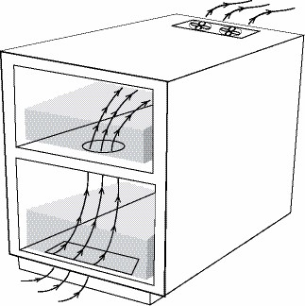
Both “active exhaust, passive intake” and “active intake, passive exhaust” are suitable
arrangements when resistance to airflow is low,
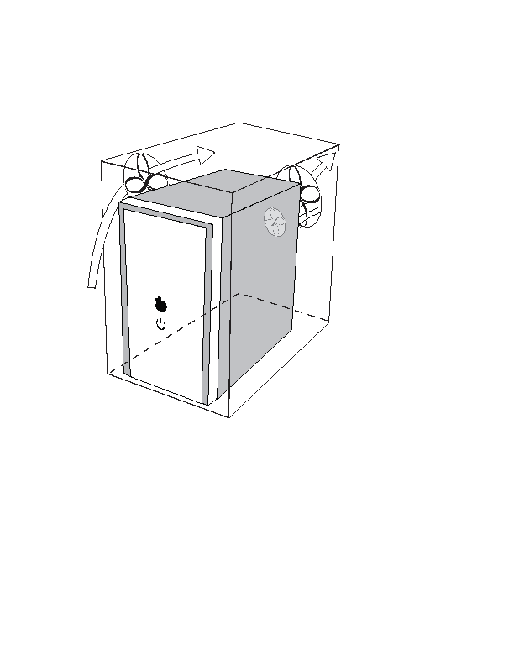

Parallel mounting
Series mounting

which is usually the case when only one or two devices are located within an uncrowded enclosure. Under these conditions, the SEC-1 would simplify installation.

If the air path were restricted significantly, as it would be if the enclosure were only very slightly larger than the devices within, or if the air path were very long, or “went around corners”, series mounting of the fans would be the preferred mounting arrangement. In series mounting, one fan is used to pull fresh air in, while the other fan pushes the heated air out. In this scenario, the System 3 would be easier to use.

In either mounting arrangement, the most effective cooling is accomplished by capturing the hot air as it comes out of the computer, and immediately moving it out of the enclosure. Usually, this means having either a passive opening or exhaust fan as close to the computer’s power supply as possible, with the fresh air intake fan or passive intake opening on another surface of the enclosure, preferably near case fans which draw air into the computer.

Two points remain; air filtration and making certain that we have sufficient cooling:

- A word about air filters (actually 3 words!): Don’t use one.

We are frequently asked about filtering the air used to ventilate home theater enclosures, and the same advice applies to computer cooling…..

While dust removal has an “apple pie and Motherhood” appeal, experience has taught us that however good the user’s intentions, filters don’t get changed; they quickly clog and block air flow. There may well be the ultra-conscientious user who really will clean or change a filter without fail…..but we have yet to meet him (or her).

Dust, however unsightly, does far less harm then heat. As dusty as they become from breathing floor-level air, unenclosed computers do not filter the air used to cool them, either.

Another reason for avoiding filters is that the resistance to air flow that even a clean filter presents requires more powerful fans than a filterless system, increasing noise level.

- For the nervous among us…

There is a relatively simple test you can perform that will indicate whether you have provided sufficient ventilation for the computer or other device you've enclosed:

1. Using a digital thermometer with an external probe, (readily available at electronics retailers), measure the temperature of the computer's exhaust air when it's sitting out in the open. Accuracy is not terribly important; repeatability is, but even low-priced digital thermometers tend to have good repeatability. (Good “repeatability” just means that even though the temperature is 90 degrees when the thermometer says it’s 95 degrees, it always says “95” when it’s 90 degrees.)

Tape or otherwise fasten the probe to the computer case so that it can't move. Let the computer run long enough to insure that it's as hot as it's going to get, i.e., the thermometer reading is steady. Note the temperature and turn the computer off.

2. Carefully place the computer (and any other equipment that will normally be there) in the enclosure, not allowing the probe to shift position. Feed the probe wire out of the enclosure so that you can measure the computer's exhaust temperature while it's mounted in its normal operating position. Turn the computer and any other equipment on and ensure that the thermal switch turns the fans on after a short delay.

3. Let the computer run until the temperature of the exhaust stream again reaches its highest temperature.

If the exhaust temperature hasn't increased by more than a few degrees over the original reading, the computer is being properly ventilated. It's possible that the temperature may even decrease slightly, indicating that the extra ventilation is causing somewhat higher airflow through the computer than normal.

Word and Excel are registered trademarks of Microsoft Corporation.
PlayStation is a registered trademark of Sony Corporation

Contact Active Thermal Management at (661) 294-7999 M-F, 8:30 - 4:30 PST for the name of your closest distributor, for more information on the products mentioned above, or to request a catalog showing our many other quiet cooling products.

We manufacture a complete line of equipment and enclosure coolers designed to make the designers' and installers' jobs easier.

See us on the Web at www.activethermal.com.

