A white paper from Active Thermal Management
The trusted name in thermal protection

By Frank Federman, CEO

Cooling the (almost) impossible enclosure with a “snorkel”

The installer will, more often than he would like, run into a home theater installation in a
cabinet that seems impossible to cool. You’ve probably run into it (or one very much like
it) yourself…. It’s built-in, of course, and can’t be moved. It often backs up to an outside
wall, so forget venting into little Johnny’s bedroom closet… The left side butts up against
a fireplace, and the right side either (pick one) ends at a wall, continues into the next
cabinet, or is considered untouchable by the wife. The top? No – either we can’t get
permission to use the top for ventilation, or it’s made of granite…!

Closets can be difficult, too – they can be located at the intersection of two exterior walls,
with the third wall blocked by a fireplace or cabinetry. This paper will refer to cooling
cabinets, but the general principles described apply to closets as well. Details specific to
closets will be italicized.

The cabinet was designed and built with no thought given to cooling the audio-video gear
that was to be housed within it. You can be sure that the owner gave a lot of thought to
that gear – you probably spent a LOT of time discussing it with him! The cabinet maker
was told to “allow for ventilation”, and said he would...
He didn’t.

Now the ball is in your court, but it’s more of a hot potato, with the emphasis on “hot”.
Mr. Satellite Receiver, or Mr. Cable Box, (both hi-def, of course) is going to run 24/7,
and boy, do they throw off BTU’s! Let’s not forget Mr. TiVo, either! Add in the multichannel receiver, DVD player, and Junior’s video games and you have a bake-at-350-
degrees-until-done recipe for trouble. Don’t give up yet – there’s probably a way out of
this. The magic words are “basement” and “crawl space”. (Readers in California and
Florida may want to look these words up in their dictionaries, after which they can stop
reading this paper.)

An accessible space below the cabinet, be it a full basement or just a crawl space, can be
just the place to dump that overheated air. If the air quality in the space is acceptable, it
can also be a source of “make up” cool air. (Remember – for every cubic foot of hot air
we move out of the cabinet, an equal volume of fresh air must enter.) There’s a bit of
work to be done, but it isn’t difficult, especially if the basement is unfinished or the crawl
space has enough headroom to allow you to work comfortably.

The plan is to pull the heated air out of the cabinet and exhaust it into the lower level, the
term we’ll use for the rest of this paper, because “basement or crawl space” is too long!
Make up air is supplied either by air from the lower level or the room in which the
cabinet is located. Let’s start by assuming that the air in the lower level is free of odors,
dust, dampness, and bugs – it’s good enough to bring into the cabinet and living space;
this leads us to “Plan A”, and yes, there is a Plan B…

Following Plan A, we get ourselves down to the neighborhood home improvement store,
orange or otherwise. We buy a 5’ length of 3” PVC or ABS tubing and a hole saw that’s
just a little larger in diameter than the tubing. You’ll need a bit extension for your 3/8”
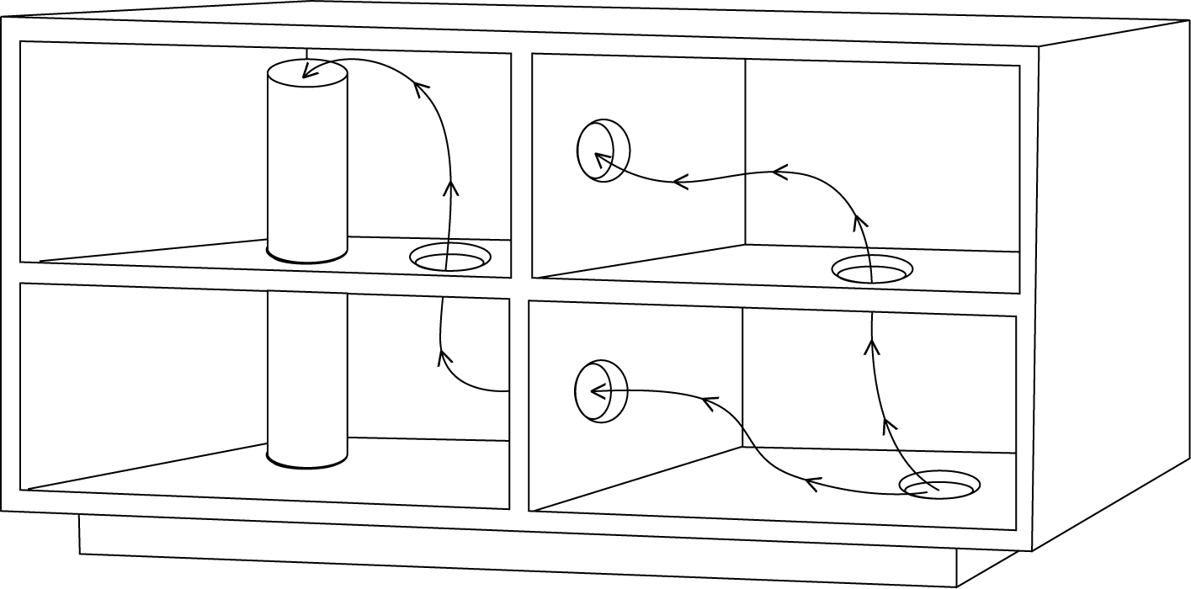
(or larger) drill, because
you’re going to be making
a hole in the floor of the
cabinet near one of the rear
corners and down through
the floor itself so that you
can create a “snorkel”
running from just an inch
or so below the top of the
cabinet down into the
lower level where it can be
attached to the intake
(suction) side of an Active Thermal Management Cool-cube®, ordered with 4” flex
tubing.

If we’re cooling a large, or walk-in closet, the Cool-cube may not have the
power needed. The System 1, a similar but more powerful product, may be required.

The general layout is illustrated above. If there are any shelves or vertical dividers in the
cabinet, you’ll have to make generous (two 3” minimum or one 4”) holes in these as well,
to ensure free air movement. The Cool-cube is going to pull the hot air down from the
cabinet’s interior and exhaust it into the lower level. Plumbers’ tape, actually a
perforated metal or plastic strap, can be used to support the bottom end of the tubing;
fasten it to the closest floor joist or the underside of the subflooring.
An easy way to mount the Cool-cube fan unit is to fasten a 16” length of 1x8 shelving
between the bottom edges of 2 adjacent floor joists, creating a small shelf. Place the
Cool-cube on the shelf, and run a short length of the 4” tubing from the intake (suction)
port to the bottom of the vertical tubing. The fit won’t be exact; use duct tape and a large
adjustable worm-gear hose clamp to make the connection. No connection is made to the
exhaust port of the Cool-cube.
A second hole is made from the lower level up into the cabinet near the front corner
diagonally opposite the exhaust tubing hole. Here, the tubing is cut just long enough so
that it’s flush with the cabinet floor and extends down into the lower level an inch or so.
This opening allows cool air to flow up into the cabinet, replacing the hot air we’ve taken
out. No connection is made to this section of tubing; it’s just a passive connection
between the lower level and the interior of the cabinet.
There will be situations in which the quality of the air in the lower level is not good
enough to bring up into the living area. (Even if this is true for only part of the year - “the
rainy season”, the lower level air should not be brought up into the cabinet.)

Time for…….. Plan B!

Plan B uses the same snorkel arrangement as Plan A to exhaust the hot air into the lower level, although it may be desirable in some cases to use an ATM backdraft damper, or one-way valve, to keep air from “backing up” into the cabinet and out into the living space when the fans aren’t running. In Plan B however, we create an intake opening in the cabinet to allow room air, rather than lower level air, to enter. The best location for such an opening is in the front, as low as possible, and on the side opposite the vertical exhaust tube (“snorkel”). This will create a cooling air flow in three dimensions; left to right, front to back, and bottom to top. If the cabinet has a recessed base (similar to a kitchen cabinet), one way to provide an
intake that’s invisible when the cabinet doors are closed is shown here; note that the slot
is cut into the cabinet floor forward of the base, just behind the doors. So that it is always
open, but hidden from view when the doors are closed
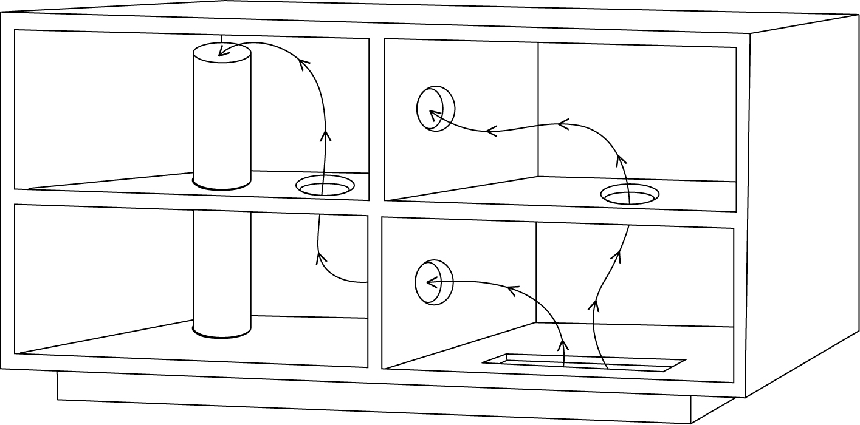
If the cabinet does
not have a recessed
base, we have to
use our
imagination. It’s
possible, if one
side of the cabinet
ends at an interior
wall, to create an
intake opening by
going through the
wall. With luck,
the other side of the wall is in a utility room, laundry, or a spare bedroom, and you can
finish the opening with a wood grille (available from Active Thermal Management in
different sizes and species of wood) which can be painted to match the wall.
The same approach can be used if the back of the cabinet is on an interior wall, although
this will result in less back-to-front air movement. If one side of the cabinet is visible, and
the owners don’t want it used for ventilation, it’s time for a frank discussion of the
consequences of not providing ventilation. The thought of replacing equipment every few
months may have a chilling (pun intended) effect….!

A skilled woodworker could rout and finish the edges of several 3/8” wide slots near the
lower front corner of the side, to integrate ventilation through what would appear to be an
element of the cabinet’s design. (If it’s done by the original maker of the cabinet, it might
convince him to take ventilation requests more seriously next time!)
Air inlets for closets can be easier. A ¾” gap under the door works well, and usually
does not cause an esthetics problem. Beware of closets with fully louvered doors; air may
enter through the top louvers, go directly to the exhaust tube, and exit, without cooling
the equipment. We recommend covering the top 2/3rds of such a door to ensure that air
enters at the lowest level, cooling the equipment as it flows to the top. The covering can
be fabric, as there will be no air pressure forcing air through the fabric; the air will enter
through the bottom third.

Cooling closets large and small in homes without lower levels is covered in a white paper
titled “Cooling Large Home Theater Systems”. This paper and several others covering a
wide range of cooling problems can be downloaded from the Technical info page at
www.activethermal.com.

A word about fabric-covered openings – no air will enter through them, and you
wouldn’t want it to! Quiet fans do not generate powerful air currents, and the
lightest-weight fabrics block airflow almost completely. If a sufficiently powerful fan
system were used, it would be very loud and the fabric would act as a filter; in a
short period of time, the weave would fill with dust, the fabric would discolor and
stretch out of shape. There are ways to filter the air going into an enclosure (and
Active Thermal Management can supply them), but moving air through cloth covered
openings is not practical.

We have our exhaust, and, one way or another, our intake established; let’s finish the job.
If there’s an AC outlet near the Cool-cube, use it; if not, plug the wall-type power supply
into an outlet inside the cabinet and make a small hole for both the low-voltage DC
power cord and the thermal switch assembly to run from the interior of the cabinet to the
Cool-cube fan unit. Alternately, by slitting the flexible tubing in the lower level, both the
DC power cord and the thermal switch assembly can be run through the vertical tubing.
More detailed instructions for Cool-cube and System 1 installations are included with
each unit, and can be downloaded from the Technical info page at
www.activethermal.com.

Contact Active Thermal Management at (661) 294-7999 M-F, 8:30 - 4:30 PST for the name of your closest distributor, for more information on the products mentioned above, or to request a catalog showing our many other quiet cooling products.

We manufacture a complete line of equipment and enclosure coolers designed to make the designers' and installers' jobs easier.

See us on the Web at www.activethermal.com.

