A white paper from Active Thermal Management
The Trusted Name in Thermal Protection

By Frank Federman, President

Cooling the mid-size enclosure

While there situations in which you install basic systems in very small enclosures, such as the receiver and CD player in a bedroom nightstand, or a computer in a kitchen cabinet, and those involving elaborate systems in large enclosures, such as the 3 racks full of gear in a separate equipment room or closet, most installations involve the "mid-size" cabinet.

"Mid-size" describes a range of enclosures from 10-12 cubic feet (2' wide x 2' deep x 2 ½' high) to 30-35 cubic feet (4' wide x 2' deep x 4' high). Construction is typically wood, whether the enclosure is a new cabinet built specifically to house home entertainment/home theater components, or an older piece of furniture designed for less technical purposes. In either case, the cabinet may have one or more shelves to hold equipment, while the wider ones may have both vertical dividers and shelves.

Installed in existing homes, these cabinets may simply be placed against a wall, exposing one or both sides. The back may be several inches from the closest wall, greatly facilitating ventilation. In newer homes, an alcove is frequently created in the family room into which an enclosure can be slid, or the enclosure is "built-in", a permanent part of the room's structure. In these cases, one or both sides may not be available for powered or passive ventilation openings.

One feature common to stand-alone and built-in enclosures is the presence of a door, ensuring that the audio and video components inside the cabinet will have very little (meaning "no") ventilation unless the designer or installer "makes it happen". This is usually not difficult; our company, Active Thermal Management, makes, as of this writing, close to 20 devices and systems that can quietly ventilate these cabinets, as well as the very large and very small.

Working with designers and installers, we suggest products to prevent (more often, stop) equipment overheating. It will come as no surprise to the reader that while we can usually solve the technical issues of CFM's, BTU's, and dB's in a few minutes by telephone or e-mail, satisfying the esthetic considerations ("you want to put a hole WHERE???") can be considerably more difficult, and certainly more time-consuming. In almost all cases, by describing the damage that is being done to the client's expensive equipment by allowing it to overheat, compromises can be reached that will keep all parties, if not happy, at least cool - pun intended. We have more than one A/V dealer who will not install a system UNLESS the owner agrees that ventilation is essential and MUST be provided. Those dealers feel, with justification, that avoiding the nuisance service calls, shortened equipment life, and general dissatisfaction that overheating can cause is worth the "extra sell" up front.

The owner is paying a designer or systems integrator at least partly for his expertise; both the owner and the installing company benefit when systems run cool.

So we've described the cabinets, and we agree we need ventilation. How do we get it? How do we keep both the electronics - and the client - cool?

At Active Thermal Management, we talk to installers every day about solving these problems. After several years of experience, we note that, while there are exceptions, the great majority of "mid-size cabinet venting" problems can be solved with just a few basic techniques. There's no math involved; no knowledge of thermodynamics needed. Most home theater systems are comprised of similar types of equipment, and generate similar amounts of heat; we've chosen fans and designed control systems to remove the BTU's generated.

We have developed a group of fully automatic cooling products under the family name of "System 2". With four members, there's a good chance that one of the System 2 family will cool the mid-size enclosure you're working with. Whether the equipment is rack-mounted or sitting on shelves, or just piled in a heap, the original System 2, the Kit, the 2+2 Kit, or the Rack-Mount will sense temperature rise, turn the fans on slowly, then gradually speed them up if the temperature continues to rise. When the equipment is turned off, the fans will gradually slow down as the equipment cools, turning off completely as the enclosure approaches room temperature. A few words about the individual "family members", then on to "so where do I put them?"

- The original System 2 consists of two fans mounted (in exhaust mode) to a sheet of 1/8" black plastic, along with the electronic controller. It's one piece (plus a "wall-wart"), and, if there's enough cabinet wall to hold it (around 16" x 8"), very easy to install. But….sometimes space is tight, so…

- The System 2 Kit is the same product, less the plastic sheet. Completely modular, you can install the fans separately, as described later. A few more holes to drill, but much more flexibility.

- The System 2+2 (Kit) is the System 2 Kit, but supplied with four fans, for somewhat larger heat loads, or cabinets on the large side of "mid-size".

- For rack-mounted systems, the Rack-Mount System 2 is just that; 3 fans + electronics, pre-mounted to a 3-U black anodized panel. Easily mounted on the front OR rear rails, it will quietly pull cooling air through the rack.

The fans are high quality 4.7" (120mm), 1" (25mm) thick "muffin" type, which never turn faster than 2/3 of their normal speed.

A word about the fan drive electronics: it's a circuit that delivers a pulse-width-modulated signal to the fans. At room temperature, the duty cycle of the output is 0%, increasing to 100% as temperature rises. Depending on the System 2 model chosen, there are one or two thermistors to sense equipment (or air) temperature; whichever one is hotter controls the fans. Fans and thermistors can be added to basic System 2 kits if cooling needs increase, up to a maximum of two thermistors and four fans.

We have found that one or another model of the System 2 family is almost always the most cost-effective (and quietest) way to ventilate the mid-size enclosure.

Question: OK - I've got my fans; where do I put them so they'll work best?

Answer: In general, the best solutions result in cool room air entering an enclosure at the bottom front, and heated air leaving at the top rear. Wider enclosures are best cooled by adding a sideward air movement; air should enter bottom front left (or right), and exit top rear right (or left). Complex ( but as unobstructed as possible) air paths remove the most heat, and minimize the possibility of trapped pockets of stagnant air.

The simplest cases are cabinets whose backs are several inches from the closest wall. If there's one large compartment, put a fan blowing room air IN in a lower corner, and one blowing OUT in the diagonally opposite upper corner. (See figure 1.) If there are more than one compartment to be cooled, either use 4 fans (2 per compartment) or, for modest heat loads in two adjacent compartments, put an intake fan in a lower corner, and one blowing OUT in the diagonally opposite upper corner in the other compartment. One large or several smaller openings in the divider between the compartments will allow the free passage of the air as it flows from the inlet to the exhaust point. Similarly, large (4" - 5" diameter) openings in shelves allow the vertical passage of air. By making sizable openings in shelves directly beneath the A/V components, the air will be directed at the component on the shelf.

For this reason, it is best to have shelves run full depth in the cabinet, i.e., not cut short as is sometimes done to provide ventilation and facilitate cabling. This just routes the air up behind the component, cooling it inefficiently if at all. Better to make small openings or notches for wires, and force the air to go through large holes under the components. Any large openings that allow air to bypass the A/V components should be blocked, if possible.

If the cabinet back is up against an interior wall, it is frequently possible to cut through the wall and move cool air from (and heated air to) the room on the other side of the wall. (But not a garage; fire codes generally prohibit openings between living spaces and garages.)
Exhaust fan or opening
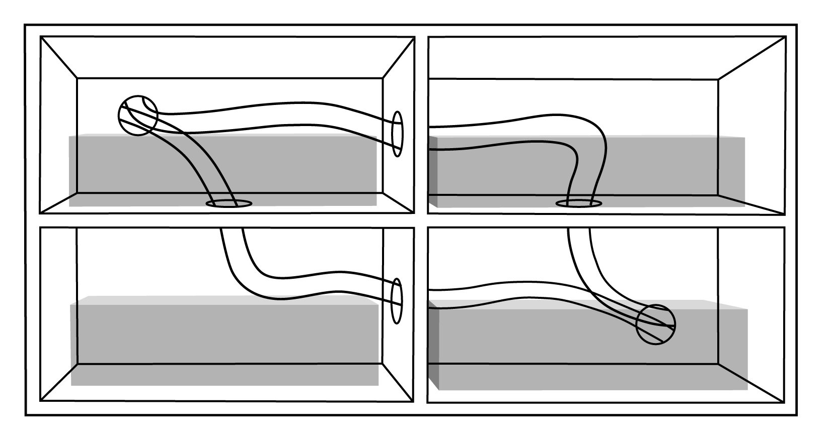
Figure 1
Intake fan or opening

A note -- It is not necessary to use fans at BOTH the intake and exhaust points. Although 2 or 4 fans will probably be necessary to generate enough air flow to provide the desired cooling, it is about as effective to either use all fans as intake devices, and have simple openings for exhaust, OR use all fans as exhaust devices, with simple openings for air intakes. These techniques are useful in situations as shown in figure 2.
Exhaust fan

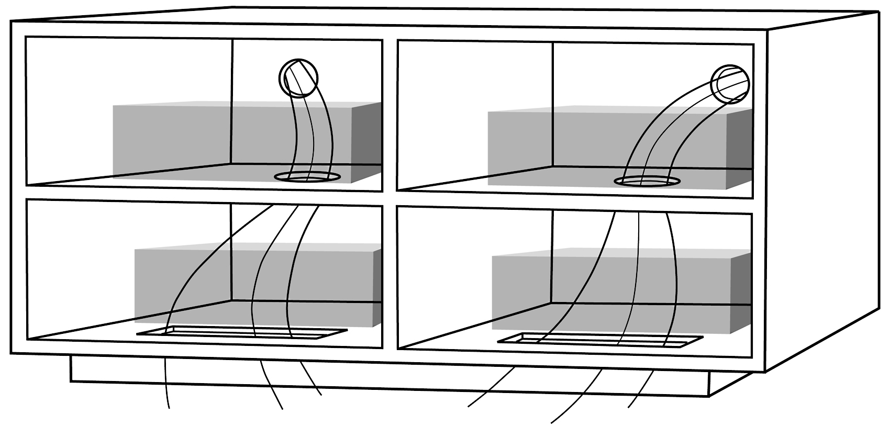
Figure 2
Passive air intake
Exhaust fan

Here, instead of fan-sized holes for air intakes, rectangular openings (usually between ¾" wide by 6" long and 1" wide by 8" long) immediately behind the doors provide adequate amounts of air to flow into the cabinet through slots that are invisible when the doors are closed. (We assume a recessed "kick panel", frequently found in A/V cabinets; when the cabinet doesn't have a recessed base, slots can be routed into the front or sides of the base, below the cabinet floor, and slots or round holes cut in the floor of the cabinet to allow the air to flow up into the cabinet.)

Figure 3 shows a cabinet in which venting through the rear is not possible. The back panel of the cabinet is up against the wall, and cannot be moved away. The wall may be an outside wall, or the room behind the cabinet may be one in which the owners don't want openings made.

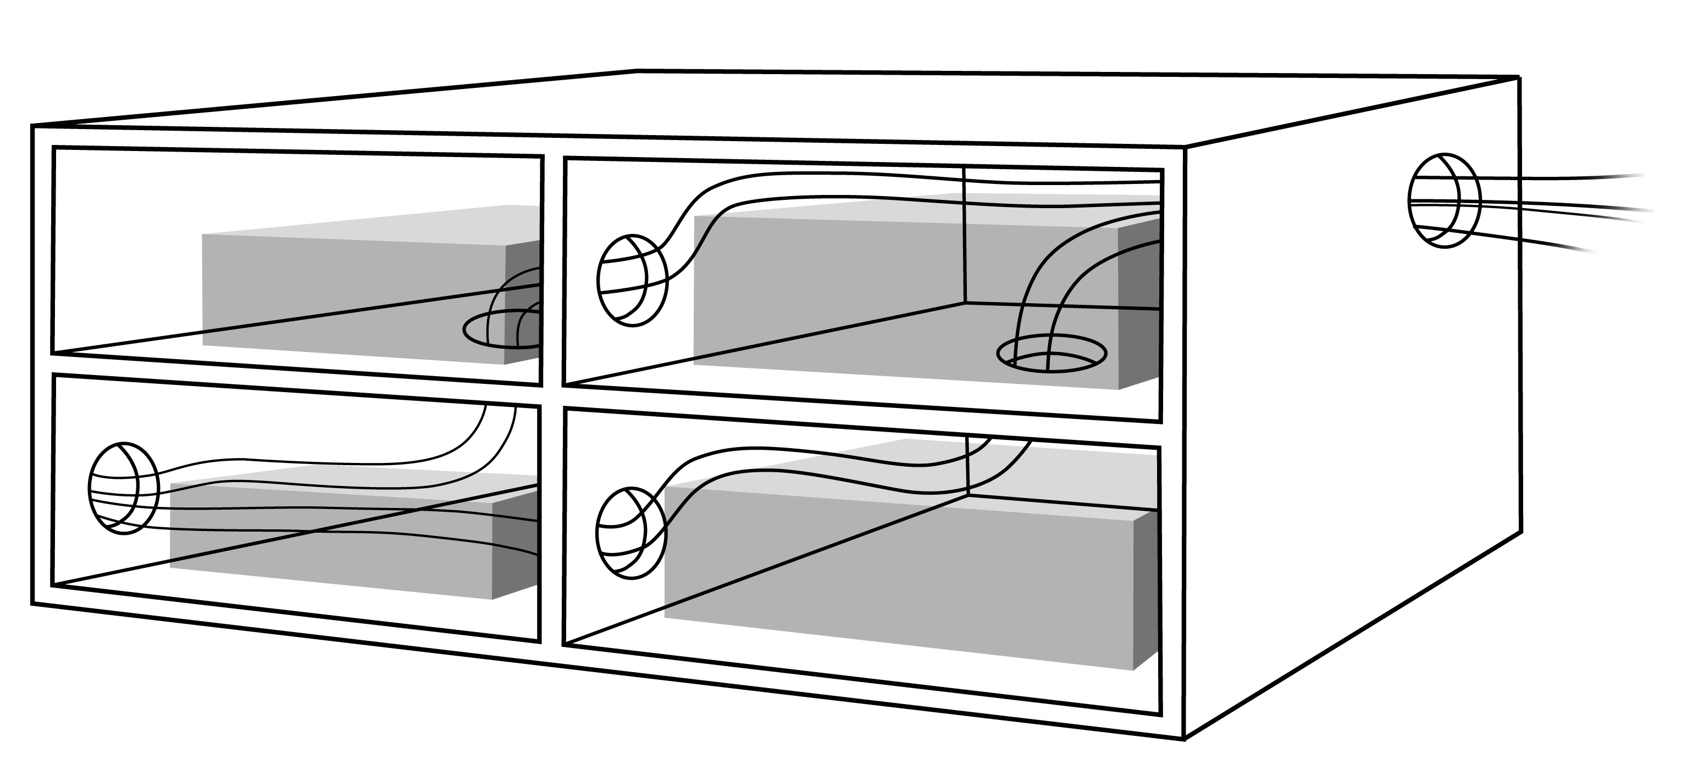
Intake fan
Figure 3
Exhaust fan

Similar to the "rear venting" example discussed earlier, we've moved the openings for both intake and exhaust from the rear panel to the sides. Note that the air is moving in all three dimensions; down-to-up, side-to-side, and front-to-back. Will owners (and their interior designers) be thrilled at the thought of making holes in the sides of their cabinets? No. Will they let you do it? Yes (usually), IF they understand the necessity of ventilation, IF they want their expensive home theater equipment to work properly, and IF they want it to do so for a long time…..

The appearance of visible openings can be improved by the use of routed slots (a job for a cabinet maker, not an installer!) or high-quality wood grilles that can be painted or stained to match the cabinetry. Active Thermal Management can supply very high quality grilles in 26 species of wood, and a variety of metals.

A few general notes:

- Do NOT expect air to move through fabric, no matter how "open" the weave. Slow-turning fans, used to minimize noise, don't have the power to force air through cloth, and, even if they could, the dust present in the air in the cleanest of houses would soon clog the weave, discoloring the cloth and stopping all air flow.

- Feel free to "mix & match" ideas seen here. Use your imagination and you can almost always find a way to bring fresh air into a cabinet low, and, preferably, in front. Similarly, a way can almost always be found to exhaust heated air high, and, preferably, towards the rear of the cabinet.

- Make any openings the air has to pass through as generous as possible. The goal is a "free-breathing" enclosure, in which relatively large amounts of air can move slowly, cooling the equipment within the cabinet without noise.

- There are many installations that consist of two equipment cabinets flanking a video display. In many cases, the video display (either CRT or flat-panel) is located forward in a central cabinet, and has open space behind it. If the display is not sealed into the cabinet, i.e., air is free to move past it, you can often vent the component cabinets "sideways" into the space behind the display, allowing the air from the side cabinets to escape into the room from behind the display. (The temperature of the air moving through a well-ventilated cabinet typically rises only a few degrees above room temperature; temperatures climb very high only when there is no air movement. For this reason, it is generally safe to exhaust heated air near other components.)
Fresh air can be brought into each of the side cabinets using methods outlined
earlier.

Drawings in this paper courtesy of our friends at Melden and Melden Advertising, San Diego

