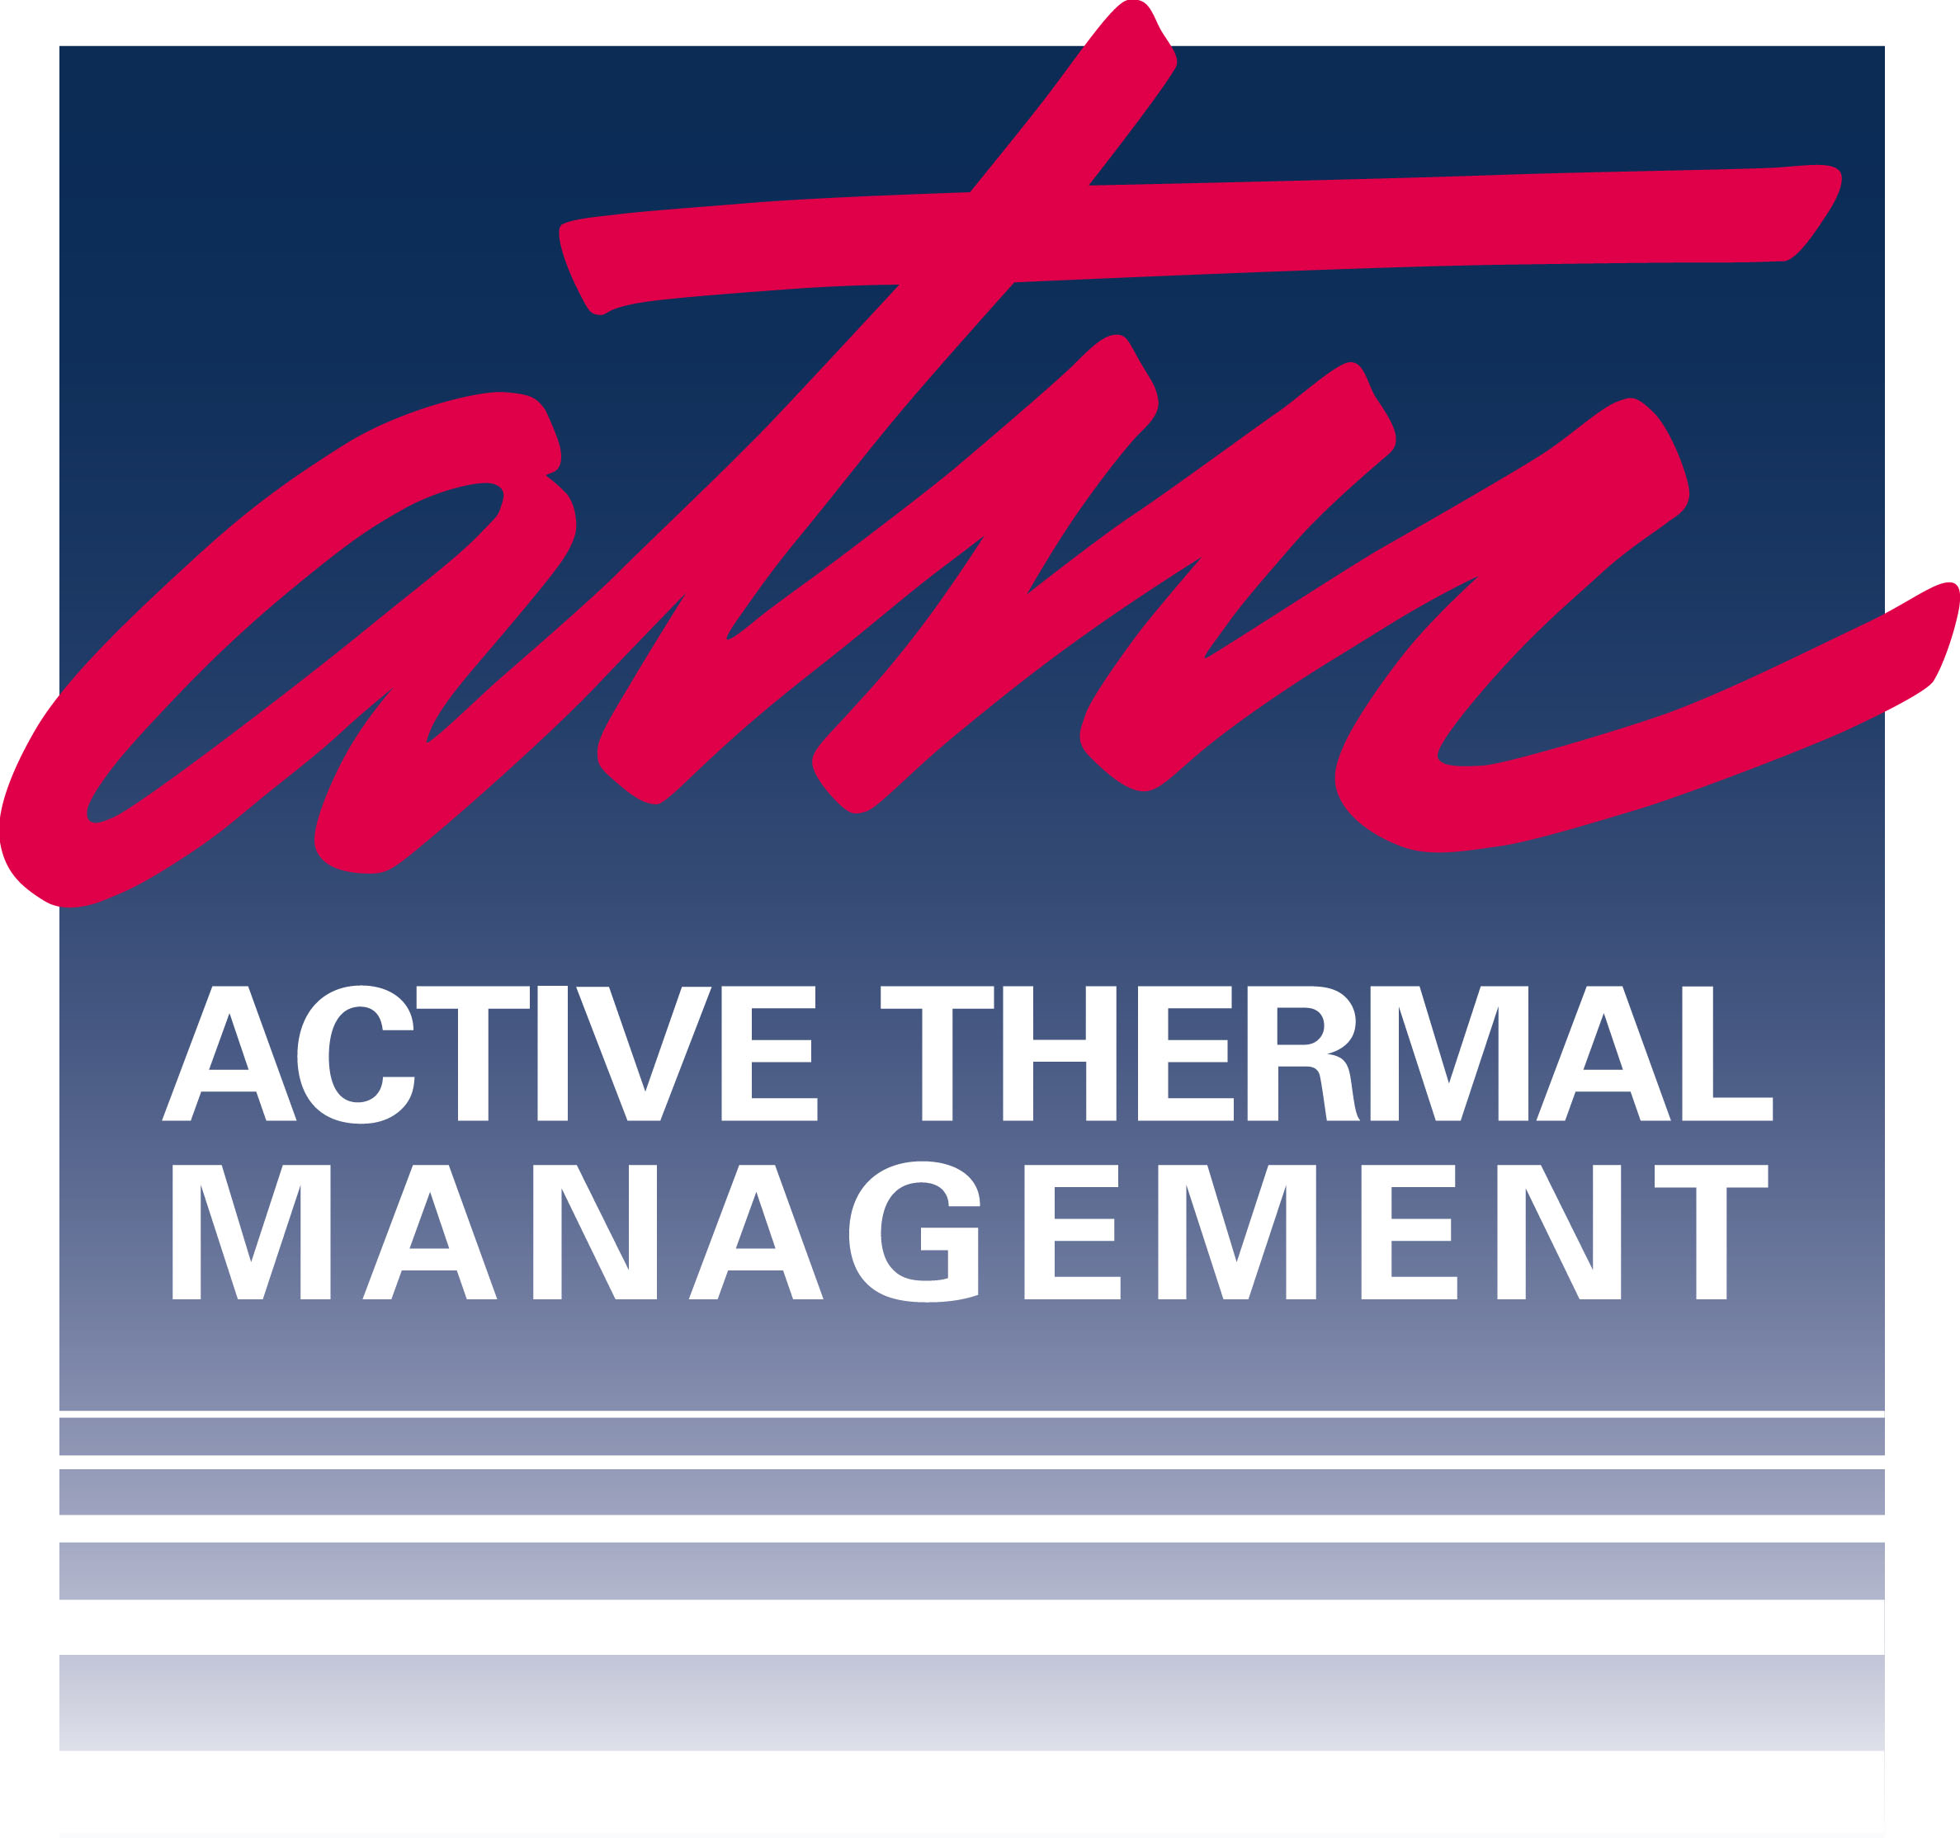

Active Thermal Management

The trusted name in thermal protection...

DEALER/DISTRIBUTOR APPLICATION

The undersigned is applying for credit with Active Thermal Management (the “Company”) and agrees to abide by the terms and conditions of the Company’s standard contract.
1. Company Name  and Address |  |  |  |  |  | DBA  (if any)
 |  |  |  |  |  | E-mail:
 |  |  |  |  |  | Acct E-mail:
 |  |  |  |  |  | Web site:
 |  |  |  |  |  | HTSA member? Yes [ ] No [ ]
2. Phone ( ) |  |  | Fax ( )
3. Your name: | Your title:
4. Walk-in store? [ ] # of locations? _________ Do you do custom installations? Yes [ ] No [ ]
5. If yes, name of senior installer
6. Name or title of persons authorized to act on your behalf :

- Approximate percentage of RESIDENTIAL installations _________

Approximate percentage of COMMERCIAL installations _________

8. Trade References (home entertainment/commercial industry references only)
Reference #1 Name and Address :
 |  | Acct #:
 |  | Fax ( )
Reference #2 Name and Address :
 |  | Acct #:
 |  | Fax ( )
Reference #3 Name and Address :
 |  | Acct:
 |  | Fax ( )
9. Bank reference
Bank account # |  |  |  |  | Phone ( )
Contact Person
Name of Bank
Address

Active Thermal Management Policies:
Free freight policy:
ATM will provide free ground shipping (in the continental US) for any order of $2000 or more. The order must ship complete to one location on one date.
Warranty:

ATM warrants all products against defects in materials and workmanship for a period of one year from date of purchase (System 1 fan units are covered by our warranty for a period of three years). We will repair or replace, at our discretion, any product which has a defect in materials or workmanship. The product being returned must be properly packaged and returned prepaid with an ATM return authorization number clearly written on the outside of the shipping carton. A copy of the bill of sale or ATM invoice to verify the original purchase date must also be included.

Credit policy:
Any product that is no longer needed can be sent back with an approved RMA number for a credit to your account within 120 days of purchase. The item(s) must be in new and unused condition. A credit will remain on your account until you choose to use it for payment. Credits can not be “cashed out.” See price sheet for current restocking fee policy.
Advance replacement policy:
If an advance replacement is requested and approved by management (via damaged product, exchange, etc.), ATM will send out the new product(s) within 24 hours as available. Advance replacements will be sent prepaid via ground shipping only- expedited shipping is available for an additional charge. The standard return period for defective or unneeded product(s) is 30 days. If the product(s) are not received within 30 days, ATM reserves the right to either charge the credit card on file or bill for product(s) not returned. If more time is needed to return the original product(s), you may contact ATM to request an extension of the standard return period.

Change in company name/address:

To update company information, please send via fax or mail a letter stating any changes on company letterhead signed by a principal of the company. ATM will not change a billing address or change a company name without signed documentation.

3+ Pricing:

Please take advantage of our 5% discount when purchasing 3 or more Active Thermal systems. It is not necessary to purchase 3 of the same product- they can be mixed. Please refer to the 3+ column on our price sheets.

We declare that the above information is true, correct and complete and is given to induce the Company to extend credit. We authorize the Company to make such credit investigation as the Company sees fit, including contacting the above trade references and banks and obtaining credit reports. We authorize all trade references, banks and credit reporting agencies to disclose to the Company any and all information concerning the financial and credit history of my company and myself:
I have read the terms and conditions stated below and agree to all of those terms and conditions as well as acknowledge the company policies set by Active Thermal Management as stated above.
Name of Company
Authorized Signature :
Printed Name :
Title : |  |  | Date :
GENERAL TERMS AND CONDITIONS
- All bills on terms become payable in full_30_ days after receipt. If not paid by such time, bills are considered past due. Distributor may have special terms.
- A service charge of 5% per month will be added to all amounts billed if not paid by the end of the month, together with interest at the rate of 1½% per month.

**Please fax to: (661) 294-1115** OR Mail to:

Any questions, please call (661) 294-7999 Active Thermal Management
25570 Rye Canyon Rd. Suite D
Valencia, CA 91355

