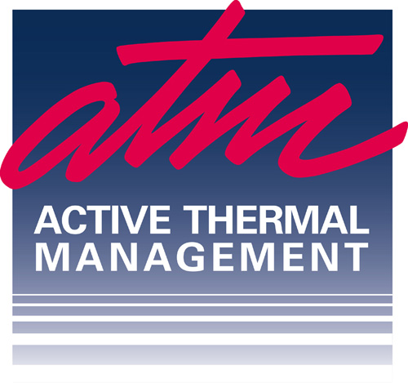

25570 Rye Canyon Rd., Suite D, Valencia, CA 91355 USA

INTERNATIONAL CUSTOMER PROFILE

INFORMATION PROVIDED IN THIS PROFILE WILL ALWAYS REMAIN CONFIDENTIAL
Date:___________________

- Type of Account: Distributor Dealer

- Company Name:

Shipping Address Line 1:

Shipping Address Line 2:

City: State/Province (if applicable):

Zip or Postal Code: ISO Country Code (2 digit):

Country:

Phone Number: Country Code:

Facsimile Number: Country Code:

E-mail Address:

Primary Contact: __________________________________________________________

Additional Telephone Numbers:

Phone Number: Country Code:

SALES INFORMATION

- Type of Business and Primary

- Sales Focus:

- Key Company Contacts:
Name: Title:

- How long in this business:

- What are the primary geographical regions and/or country covered by your firm?

- Does your company sell direct to end-users? Yes No % of sales

- Is your company a distributor? Yes No

- How many active dealers do you sell to?

Are you a CEDIA member? Yes No

Are you a member of any other professional associations or trade groups? Yes No

If yes, which?
Name Title Date

Thank you for completing this profile.
Please return to: sales@activethermal.com or fax +1 (661) 294-1115
If you have any questions, please call +1 (661) 294-7999

