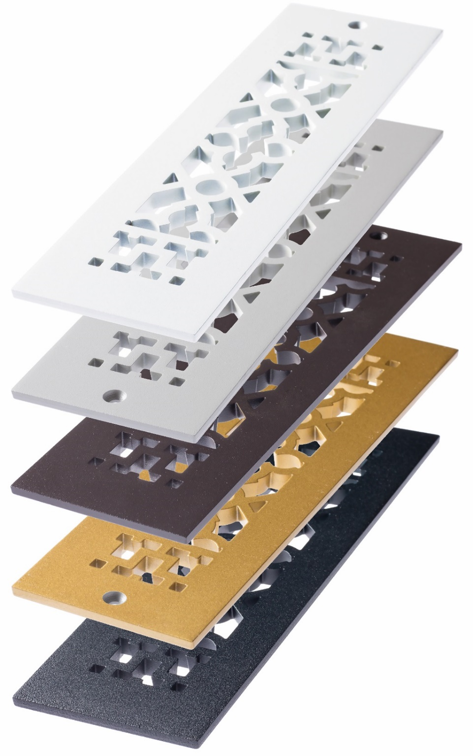 **Finishes available in aluminum and steel**

Grey

Silver

Oil-rubbed Bronze

Sun Gold

Black

**To order, substitute for “XX” in part number:**

**Traditional design**  **Modern design**

TG (grey) MG (grey)

TS (silver) MS (silver)

TB (bronze) MB (bronze)

TSG (sun gold) MSG (sun gold)

TBK (black) MBK (black)

TWH (white, not shown) MWH (white, not shown)

**Versailles design**

VG (grey)

VS (silver)

VB (bronze)

VSG (sun gold)

VBK (black)

VWH (white, not shown)